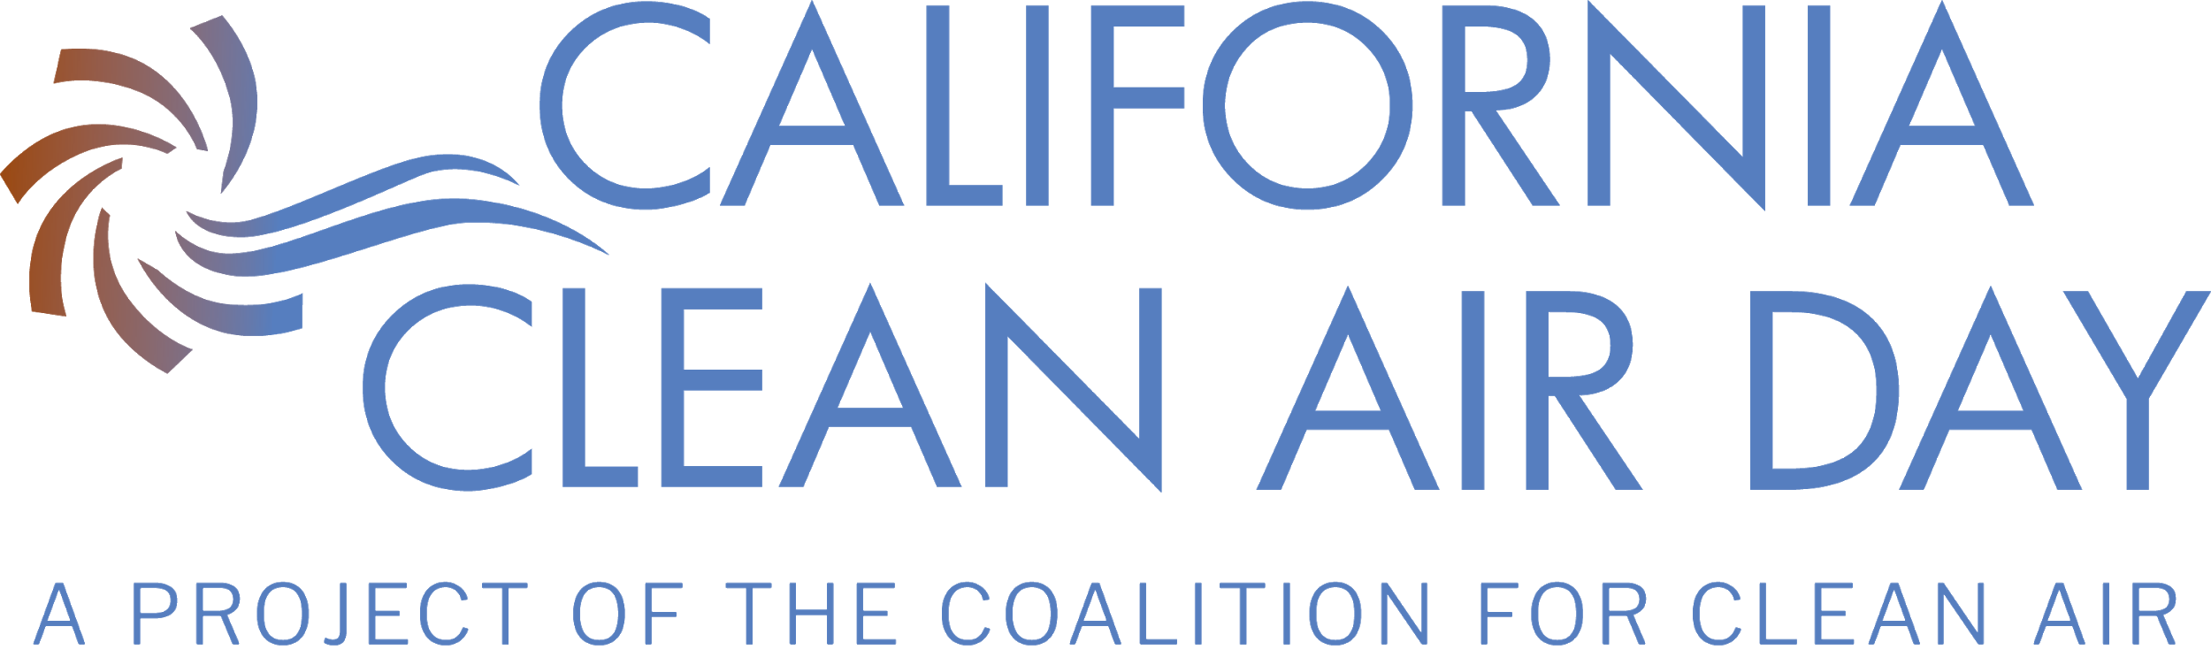
DRAFT RESOLUTION FOR
California Cities
Support for and Declaration of Clean Air Day

Whereas, air pollution contributes to higher rates of cancer and heart and lung diseases, which adversely affect health; and
Whereas, California has some of the most polluted regions in the United States; and
Whereas, it is vital that we protect the health and well-being of our residents, visitors, and workforce; and
Whereas, emissions from vehicles, industry, and even household sources significantly affects the natural environment, air quality and well-being of residents, employees, and visitors of the City of XXXXX; and
Whereas, individual actions such as not idling vehicles, walking or biking to work and school, carpooling, and conserving energy can directly improve air quality in our region; and
Whereas, everyone can play a role; and
Whereas, education about air quality can raise community awareness, encourage our community to develop better habits, and improve our community health; and
Whereas, Californians will be joining together across the state to clear the air on October 3, 2018; and
Whereas, the City of XXXXX is committed to the health of our residents, workforce, visitors, and community at large; and
Now, therefore be it resolved, by the City of XXXXX that October 2, 2019 be declared “Clean Air Day” in the City, and
Be it further resolved that we ask all City Department heads to determine how their employees can participate in Clean Air Day, as appropriate, and report back on those actions.
Be it further resolved that we encourage all residents, businesses, employees, and community members to participate in Clean Air Day and help clear the air for all Californians.

